DevOps-Build Pipeline with ORM Stack

Contents

1. Introduction 3
2. Workflow diagram to deploy the stack 3
3. Create stack for the Devops-Build Pipeline 4
4. Plan the Job 7
5. Apply the Job 8
6. Verify in the Console 10
7. Destroy the stack 10

Introduction
A build pipeline contains the stages that define the build process for successfully compiling, testing, and running software applications before deployment.
A stage is an action in the build pipeline. The DevOps service includes the following pre-defined stages that use in a build pipeline:
Managed Build: Build and test user’s software applications.
Deliver Artifacts: Store user’s software applications created from the Managed Build stage in the Oracle Cloud Infrastructure (OCI) Artifact Registry or OCI Container Registry repositories.
Trigger Deployment: Start a deployment pipeline to deploy the output from the build pipeline.
Wait: Pause a specific duration for testing the build pipeline.

Workflow diagram to deploy the stack
Below diagram shows how the Terraform Artifact are applied in the OCI. While creating a ORM stack, using terraform deliverables Init, Plan and Apply is the flow to provision the resource in the OCI. We can have the deliverables in any of below.
- GitLab/GitHub Repo
- Bitbucket
- Can be in folder/.zip in the local disk
- Object Storage Bucket
- Can be in compartment
- Oracle provided Template


Create stack for the Devops-Build Pipeline

Go to OCI Console Developer Services Resource Manager Stacks select the compartment Create Stack

My Configuration Folder Browse Select the “Build Pipeline” folder that contains the terraform Upload

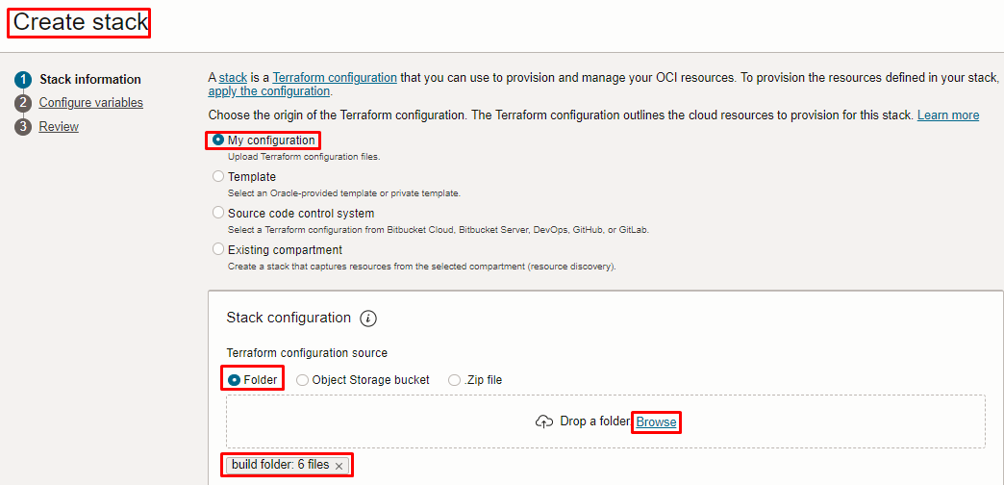

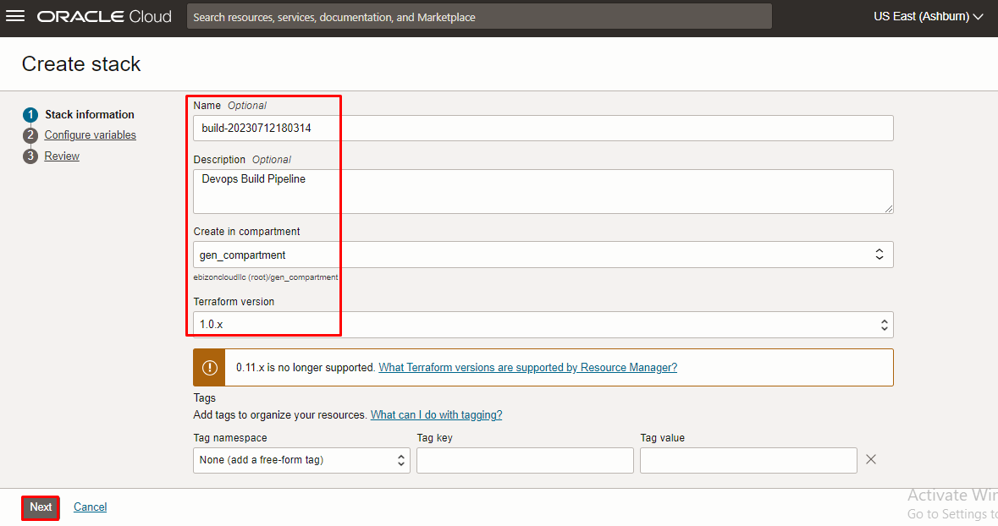

Click “NEXT”

Select the parameters as per the below screen,

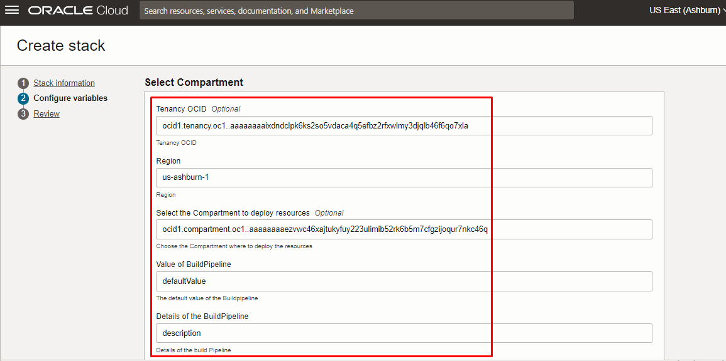

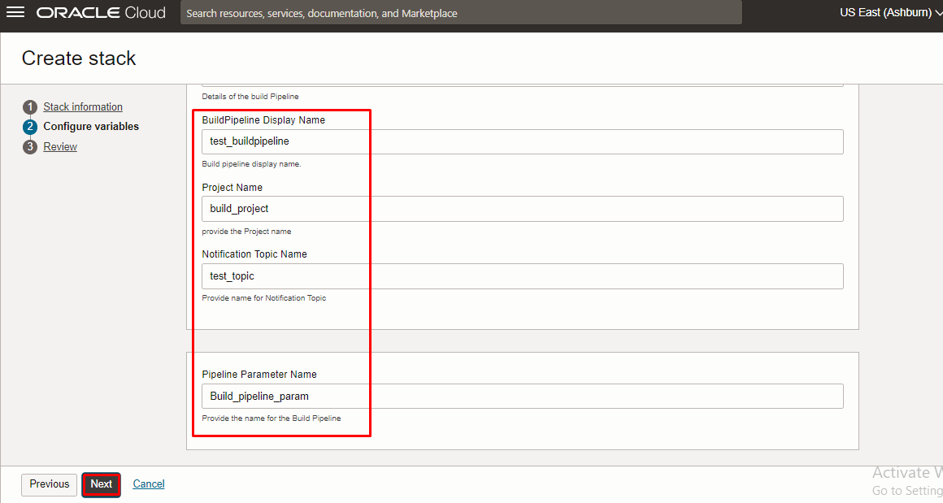
Click “NEXT” Click “CREATE”

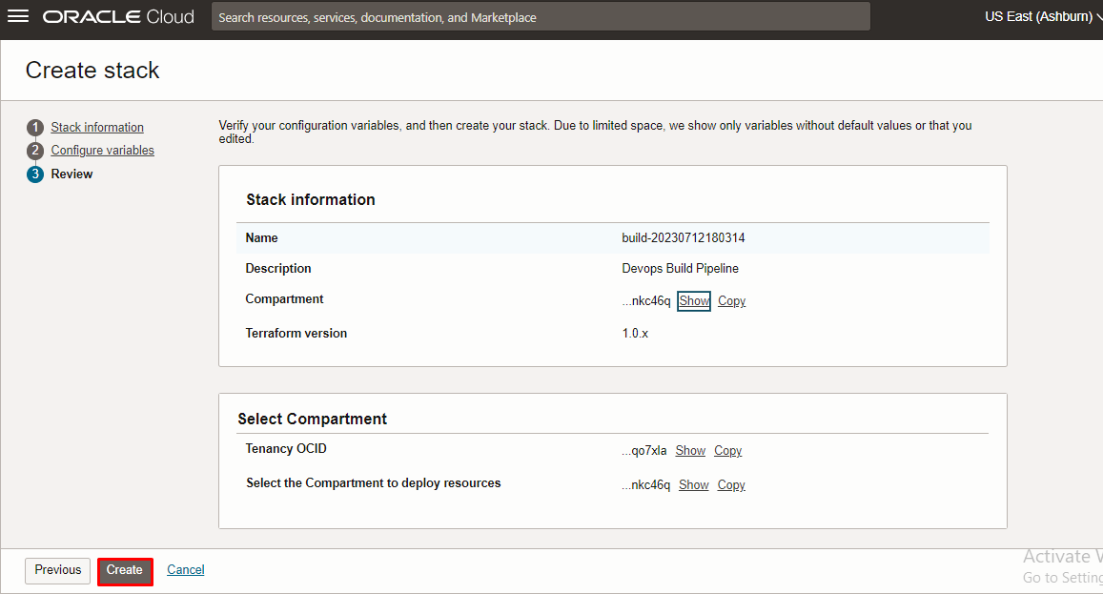

Plan the Job

Click the “Plan”

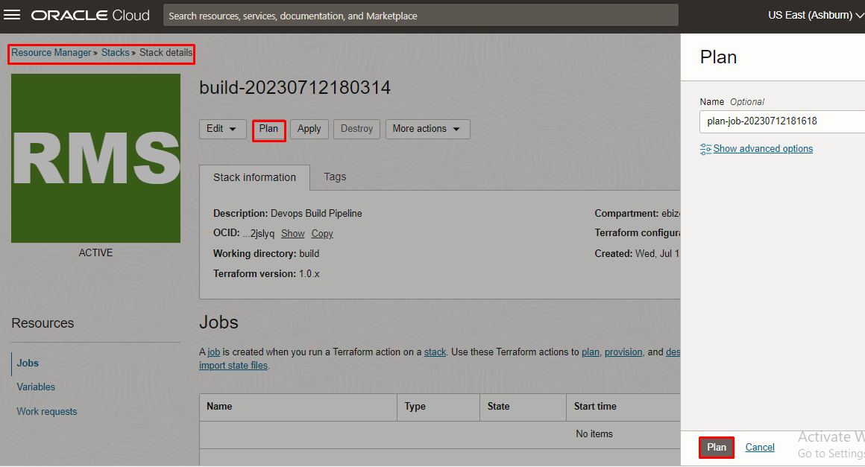

Verify the Plan is successful.

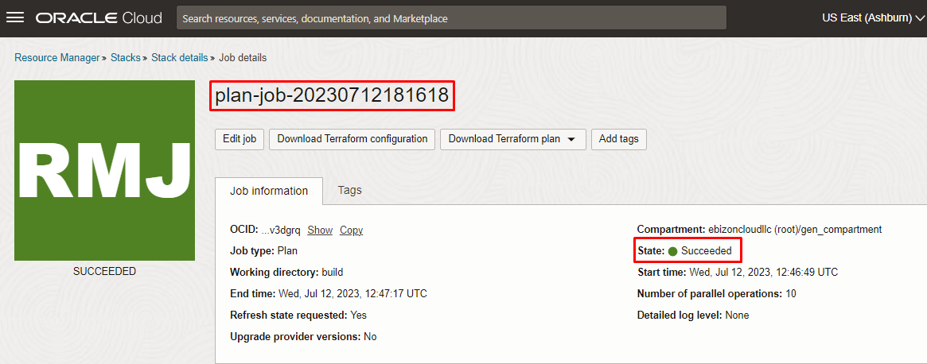

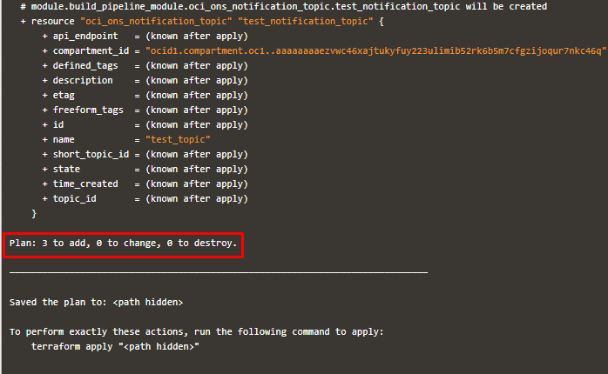

Apply the Job

Once the “plan” is success, now click “Apply”

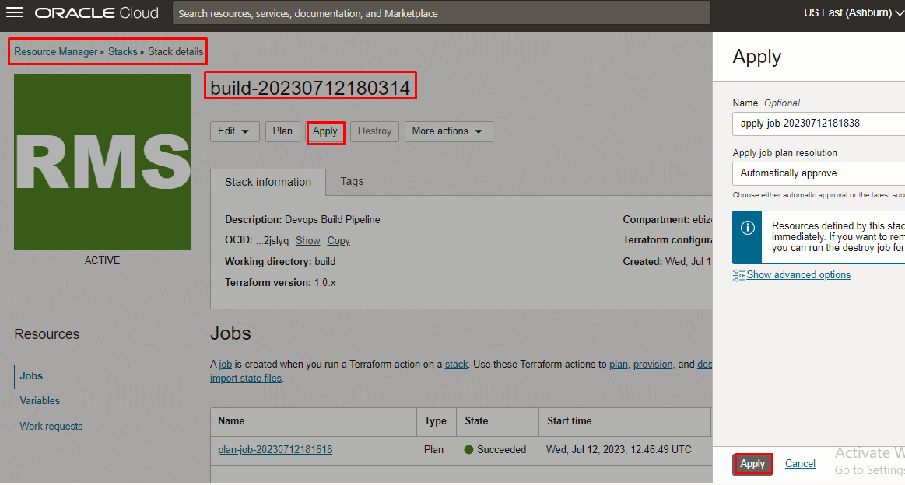
Verify the Apply is successful.
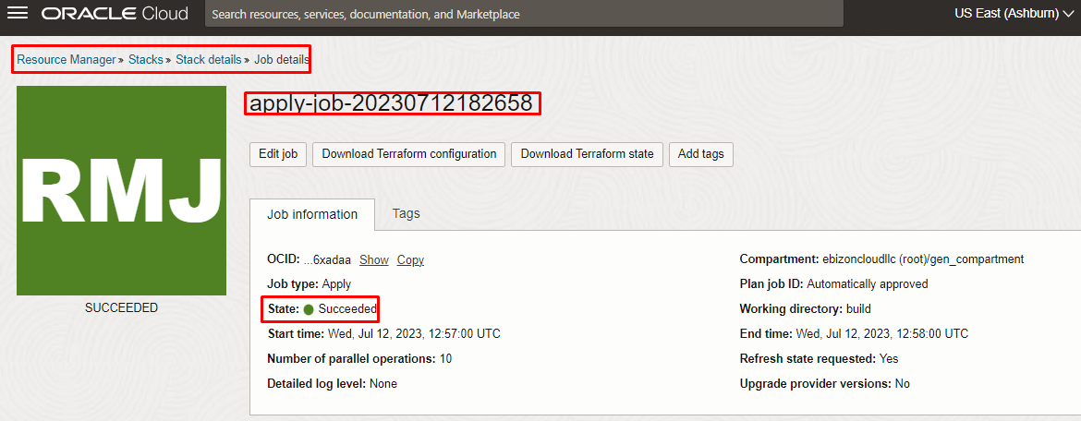

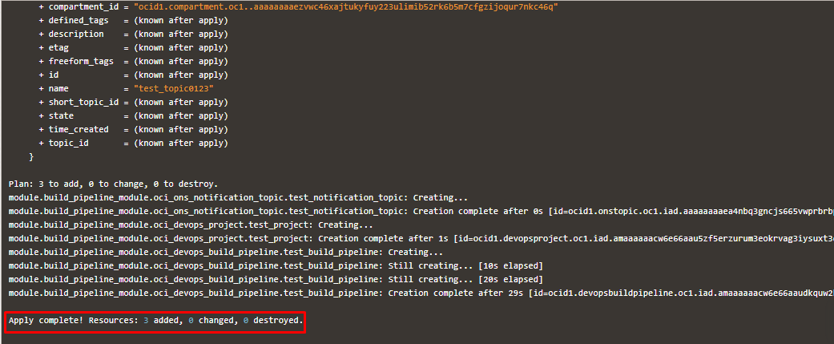

Verify in the Console

Go to OCI Console Developer Services Devops

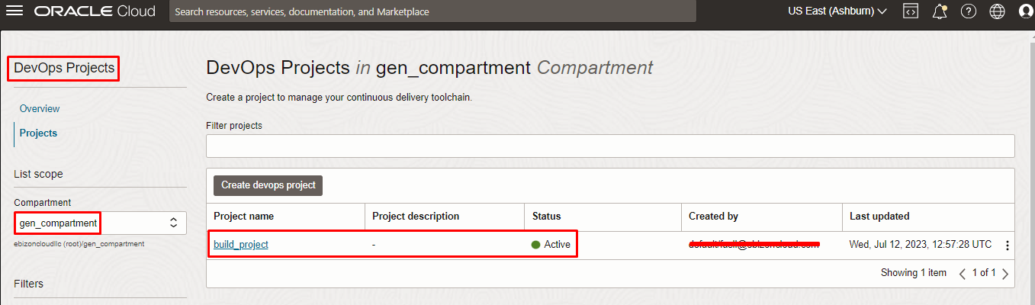

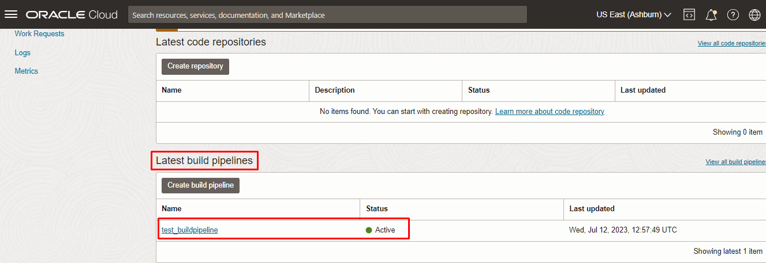

Destroy the stack

Create a destroy job in Resource Manager to release resources associated with a stack and clean up the tenancy. Once destroyed data cannot be recovered from resources.

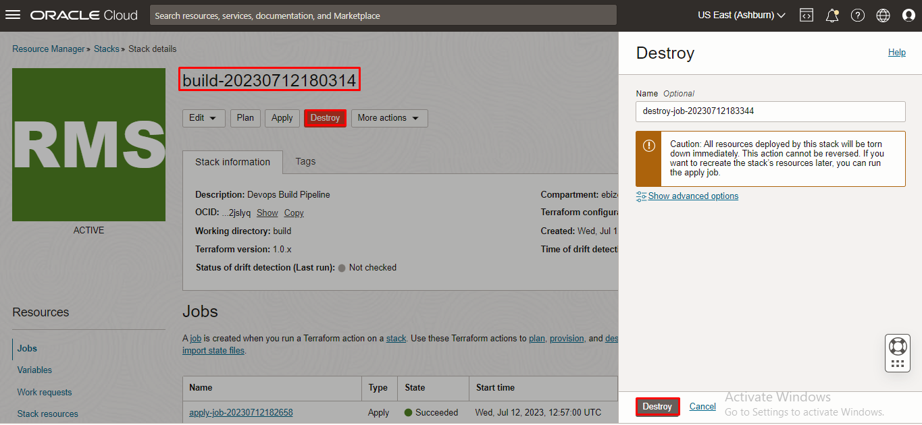

########END#######

